**POTASSIUM CARBONATE**

**HERO**

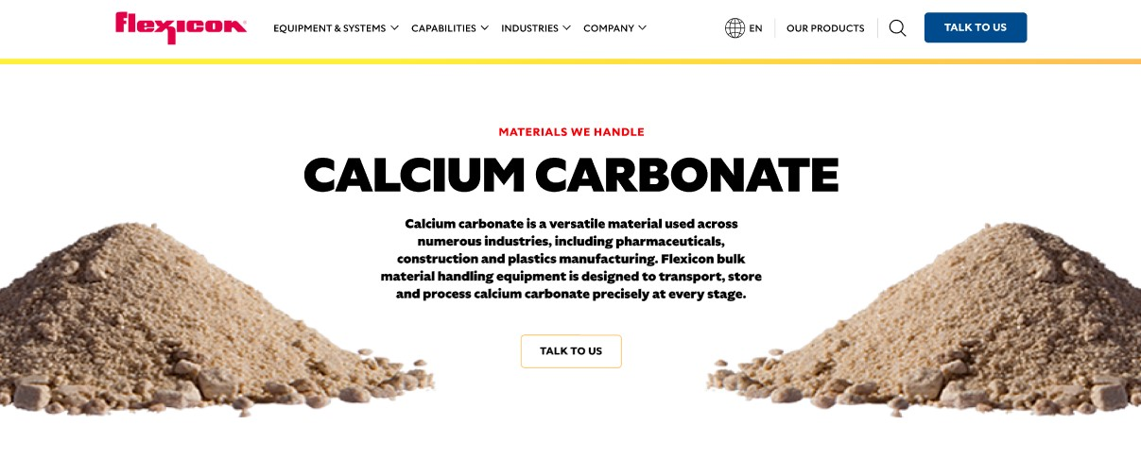

Potassium carbonate is a widely used compound in industries ranging from glass manufacturing to food processing. Flexicon equipment is purpose-built to handle potassium carbonate with precision, ensuring safe, efficient conveying, storage, and processing.

**Button**: Talk To Us

**SHELF #1 - PRODUCT DESCRIPTION**

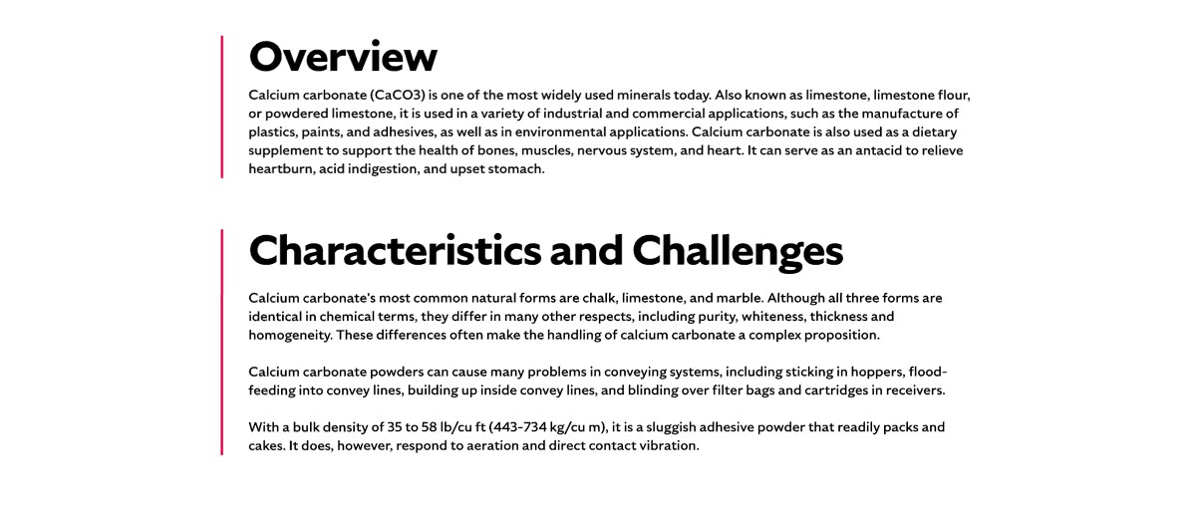

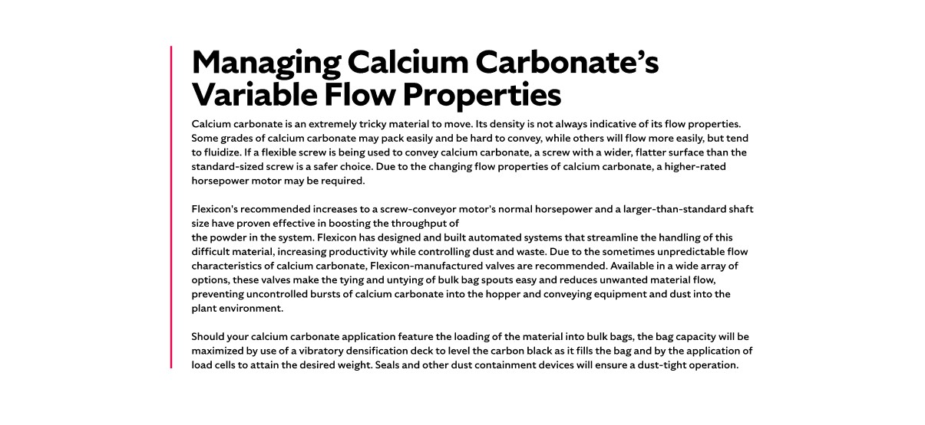

**Overview**Potassium carbonate, also known as potash or pearl ash, is a white, translucent, odorless crystalline material with mild alkaline properties. Historically derived from wood ash, it is now commercially produced through the electrolysis of potassium chloride. With applications in fertilizers, detergents, pharmaceuticals, cement, and textiles, potassium carbonate plays a vital role in both industrial and consumer products. Its hygroscopic nature and abrasive qualities make it a material that requires specialized handling solutions to maintain flow and minimize waste.

**Characteristics and Challenges**Potassium carbonate is a free-flowing, crystalline material with an average bulk density of 20 lb/cu ft. It is hygroscopic and may agglomerate when exposed to moisture, especially in micronized form. Its abrasive nature in granular form requires durable conveying equipment, and its HMIS Health rating of 2 indicates potential irritation risks. Proper handling solutions—such as spring-loaded bulk bag frames, bag-activating devices, and dust-tight seals—are essential to ensure complete discharge and safe material transfer.

To maintain flow and minimize dust, systems should include dust collectors with reverse pulse jets, vibratory hopper aids, and moisture control devices. Manual unloading can be supported with bag dump stations equipped with dust hoods and filter cartridges. Pneumatic conveying systems must be properly sized and sealed to prevent moisture ingress. For flexible screw conveying, a round screw design is ideal, while bulk bag filling can be optimized with densification decks and load cells to ensure accurate, dust-free packaging.

**SHELF #2 - FLEXICON SOLUTIONS**

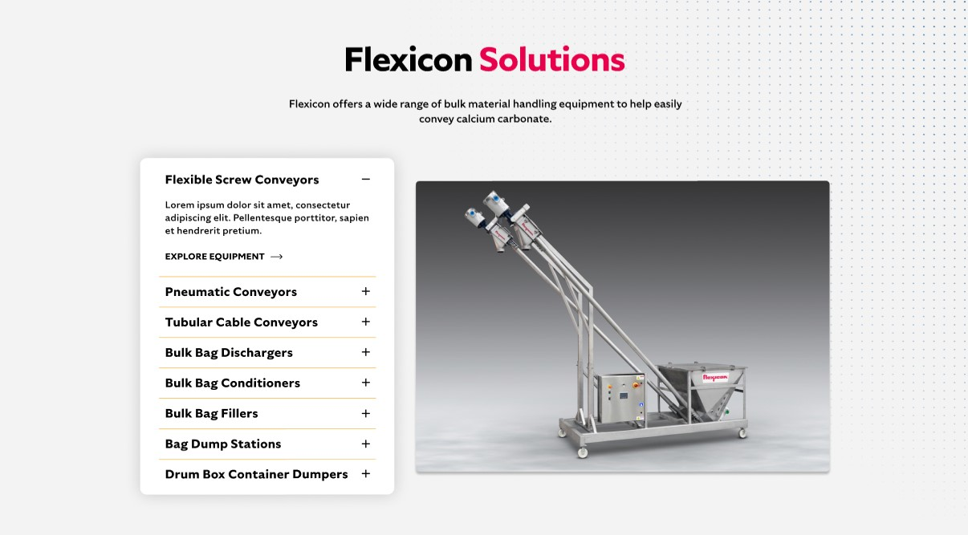

**Flexicon Solutions**

Flexicon offers a wide range of bulk material handling equipment to help easily convey potassium carbonate.

**Flexible Screw Conveyors:** Reliably transport potassium carbonate with a gentle screw motion that prevents degradation and supports consistent flow.

**Pneumatic Conveyors:** Maintain clean, efficient transfer of potassium carbonate through enclosed air-driven systems that capture and recycle dust.

**Tubular Cable Conveyors:** Offer a sealed conveying path with flexible layout options, ideal for potassium carbonate in space-constrained or hygiene-critical settings.

**Bulk Bag Dischargers**: Ensure controlled, dust-free unloading of potassium carbonate using secure spout connections and flow-assist mechanisms.

**Bulk Bag Conditioners:** Break up hardened potassium carbonate inside bulk bags to restore free-flowing properties before discharge.

**Bulk Bag Fillers:** Accurately fill bulk bags with potassium carbonate using vibration decks and automated weighing systems to reduce dust and optimize throughput.

**Bag Dump Stations:** Facilitate manual addition of potassium carbonate with integrated dust collection and ergonomic design for cleaner, safer operation.

**Drum/Box/Container Dumpers:** Transfer potassium carbonate from smaller containers into processing systems with minimal dust release and reduced manual effort.

**SHELF #3: LIFETIME PERFORMANCE GUARANTEE**

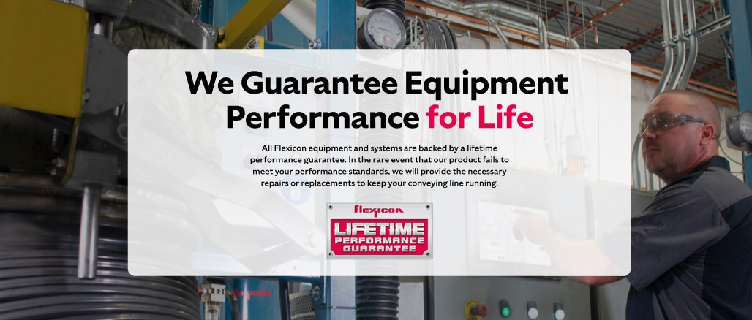

**Lifetime Performance Guarantee**

All Flexicon equipment and systems are backed by a lifetime performance guarantee. In the rare event that our product fails to meet your performance standards, we will provide the necessary repairs or replacements to keep your conveying line running.

**SHELF #4: CASE STUDIES**

